Project Case | 
ISYS6197
Business Application Development
Computer Science | E192-ISYS6197-LV01-00
Valid on Even Semester Year 2018/2019 | Revision 00

- Seluruh kelompok tidak diperkenankan untuk:
The whole group is not allowed to:
    - Melihat sebagian atau seluruh proyek kelompok lain,
Seeing a part or the whole project from other groups
    - Menyadur sebagian maupun seluruh proyek dari buku,
Adapted a part or the whole project from the book
    - Mendownload sebagian maupun seluruh proyek dari internet,
Downloading a part or the whole project from the internet,
    - Mengerjakan soal yang tidak sesuai dengan tema yang ada di soal proyek,
Working with another theme which is not in accordance with the existing theme in the matter of the project,
    - Melakukan tindakan kecurangan lainnya,
Committing other dishonest actions,
    - Secara sengaja maupun tidak sengaja melakukan segala tindakan kelalaian yang menyebabkan hasil karyanya berhasil dicontek oleh orang lain / kelompok lain.
Accidentally or intentionally conduct any failure action that cause the results of the project was copied by someone else / other groups.

- Jika kelompok terbukti melakukan tindakan seperti yang dijelaskan butir 1 di atas, maka nilai kelompok yang melakukan kecurangan (menyontek maupun dicontek) akan di – NOL – kan.
If the group is proved to the actions described in point 1 above, the score of the group which committed dishonest acts (cheating or being cheated) will be “Zero”

- Perhatikan jadwal pengumpulan proyek, segala jenis pengumpulan proyek di luar jadwal tidak dilayani.
Pay attention to the submission schedule for the project, all kinds of submission outside the project schedule will not be accepted

- Jangan lupa untuk melihat kriteria penilaian proyek yang ditempel di papan pengumuman, atau tanya asisten anda.
Don’t forget to look at the project assessment criteria that posted on the announcement board, or ask your teaching assistant.

- Persentase penilaiaan untuk matakuliah ini adalah sebagai berikut:
Marking percentage for this subject is described as follows:

Tugas Mandiri  Assignment | Proyek  Project | UAP  Final Exam
40% | 60% | -

- Software yang digunakan pada matakuliah ini adalah sebagai berikut:
Software will be used in this subject are described as follows:

Software
Software
Java 8
Eclipse Neon 2
XAMPP 3.22 (MySQL)
MySQL Java Connection Library
- Ekstensi file yang harus disertakan dalam pengumpulan tugas mandiri dan proyek untuk matakuliah ini adalah sebagai berikut:
File extensions should be included in assignment and project collection for this subject are described as follows:

Tugas Mandiri  Assignment | Proyek  Project
JAVA, CLASS | JAVA, CLASS, SQL, image files(JPG/PNG/GIF)

Soal
Case
Fish Shop

Fish Shop is a shop that sells freshwater, seawater, and brackish fish. To manage all the transactions and manage system of the fish, Fish Shop’s owner asked you to create the program for the store. The program should be made using Java Programming Language.
There are some requirements to build this application:
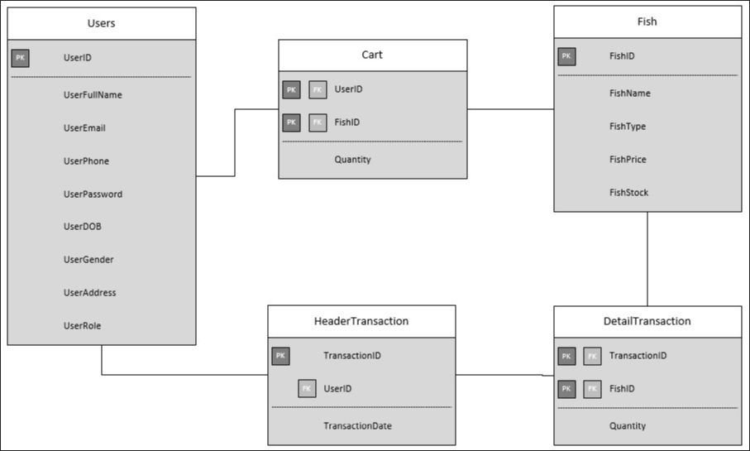
Execute the provided create and insert query file on “fish_shop” database! (“create+insert.sql”)

- Login Form
This is the first form which will appear when the program is run. Login Form is used by users to Login so the users can access the Main Form.
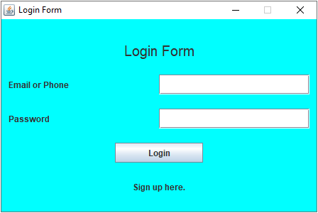
Figure 7. Login Form

Components:
- JLabel for Title, Email or Phone, Password, Sign Up.
- JTextField for input Email or Phone.
- JPasswordField for input Password.
- JButton for Login.

Description:
- If user clicks Login button, then validate:
  - Email or Phone field must be filled.
  - Password field must be filled.
  - (Email or Phone) and Password must be correct according to the existing data in database.
- If user has successfully signed in, display a JOptionPane along with the user’s name.
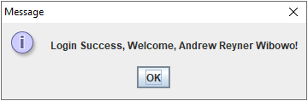
Figure 8. Success Login Message
  - After user close the message pane, program will validate either its role is “User” or “Admin”. Lastly, the Login Form will be closed, and Main Form will be displayed (Figure 1 or Figure 2 depends on user’s role).
- If user failed to login then display warning message.
- If user click “Sign up here.” label, then program will close Login Form and open Register Form.
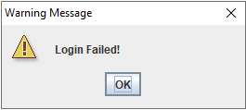
Figure 9. Failed Login Warning
(additional note: every error occurrence will be shown on error message JOptionPane).

- Register Form
Register Form is used by users to Register.
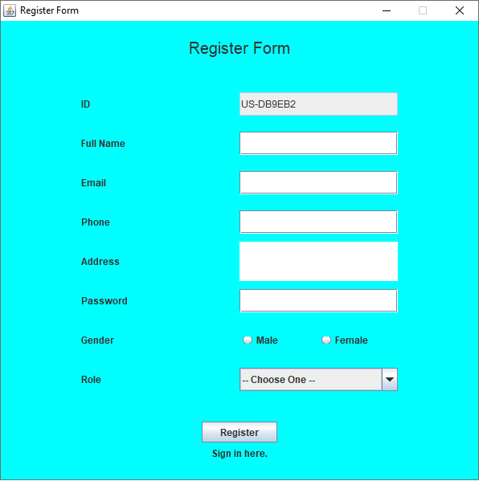
Figure 10. Register Form
Components:
- JLabel for Title, ID, Full Name, Email, Phone, Address, Password, Gender, Role, and Sign In.
- JTextField for input ID (read-only), Full Name, Email, and Phone.
- JTextArea for input Address.
- JPasswordField for input Password.
- JRadioButton for input Gender (“Male” or “Female”).
- JComboBox for choose user Role which has 3 options:
  - – Choose One – (Default Option)
  - User
  - Admin
- JButton for Register.
Description:
- If user clicks Register button, then validate:
  - ID is generated when Register Form is opened with format:
US-XXXXXX
Where X: Random Digit (0-9) or Uppercase Character (A-Z)
Example: US-A1R0W2, US-12UI9P, US-P9150H

  - Full Name must be between 5 - 30 characters.
  - Email must haven’t been taken and be in valid format:
[email]@[provider].[domain]
    - Character ‘@’ must not be next to ‘.’.
    - Must not starts and ends with ‘@’ nor ‘.’.
    - Must contain exactly one ‘@’.
    - Must contain exactly one ‘.’ after ‘@’ for separating [provider] and [domain].
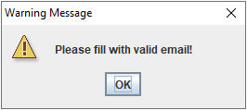
Figure 11. Invalid Email Format Warning
  - Phone must haven’t been taken and consist only 10 - 12 digits only.
  - Address must consist of 10 or more characters and ends with ‘ Street’.
  - Password must 8 - 20 length of character and digit (must at least contain 1 character and 1 digit).
  - Gender must be selected either “Male” or “Female”.
  - Role must be chosen either “User” or “Admin”.
(additional note: every error occurrence will be shown on error message JOptionPane).
- If user successfully register, insert new user data to database, then program will display a success insert message. Lastly, program will close Register Form and open Login Form.
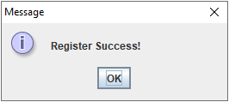
Figure 12. Register Success Message

- Main Form
This is the main form for the program. At this form the user can select menu from the menu bar, such as User Menu (Profile, Logoff, and Exit), Transaction Menu (Buy Fish and View Transaction History) and Manage Menu (Manage Fish). The menu that will show is determined by the user role. If the user role is “User”, then the menus that available are User Menu and Transaction Menu only. If the user role is “Admin”, then the menus that available are User Menu and Manage Menu.

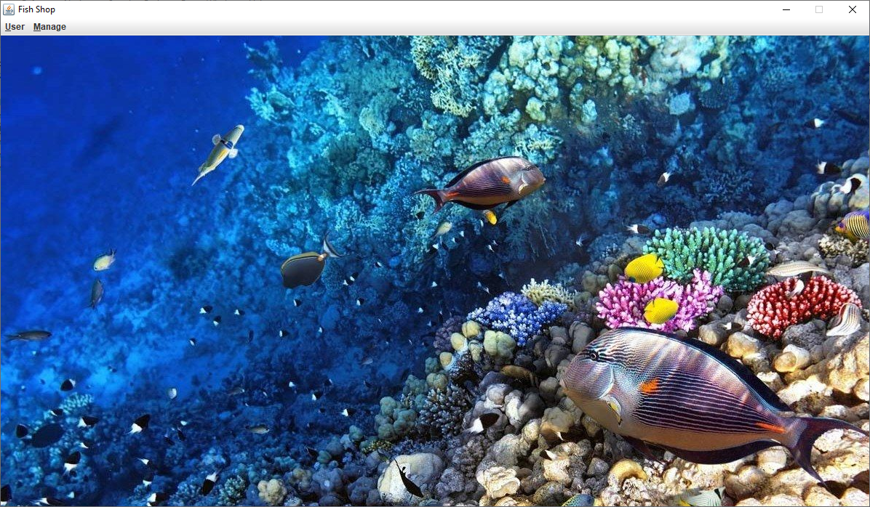
Figure 1. User Main Form
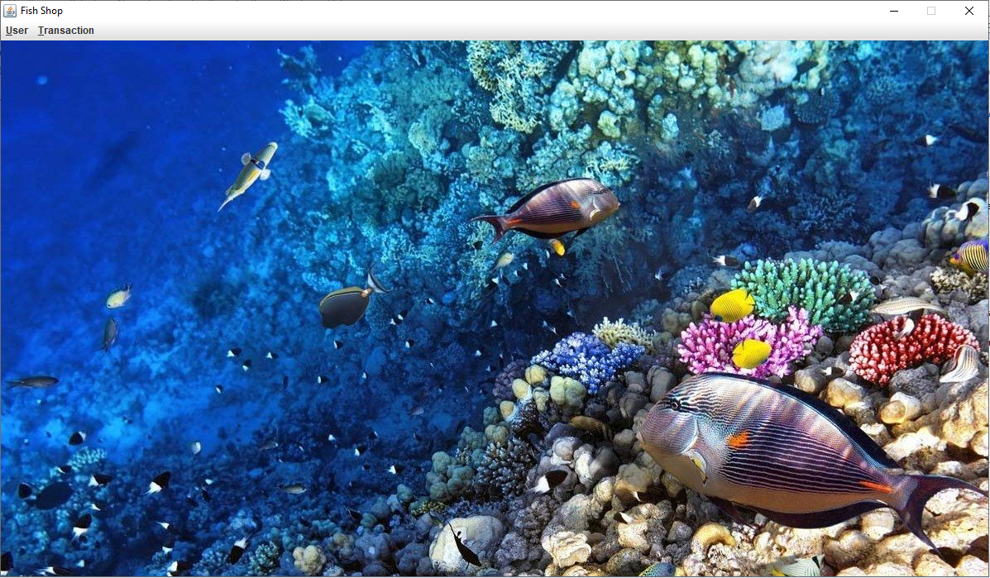
Figure 2. Admin Main Form

Components:
- User Role:
  - JMenu for Menu User and Menu Transaction.
  - JMenuItem for Profile, Logoff, Exit, Buy Fish, and View Transaction History.
- Admin Role:
  - JMenu for Menu User and Menu Manage.
  - JMenuItem for Profile, Logoff, Exit, and Manage Fish.

Description:
There are some JMenuItem that available (to be clicked):
- Both Role
  - If user clicks Profile Menu Item, then the program will open Profile Form.
  - If user clicks Logout Menu Item, then the program will close Main Form and open Login Form.
  - If user clicks Exit Menu Item, then the program will be terminated.
- User Role
There will be two JMenu displayed:
      - User
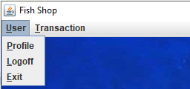
Figure 3. User: User Menu

There are 3 JMenuItem available (to be clicked) in User Menu (Profile, Logoff, and Exit).
        - If user clicks Profile, program will open Profile Form inside the Main Form.
        - If user clicks Logout, program will close Main Form and open Login Form.
        - If user clicks Exit, program will be terminated.

      - Transaction
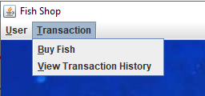
Figure 4. User: Transaction Menu
There are 2 JMenuItem available (to be clicked) in Transaction Menu (Buy Fish and View Transactioin History).
        - If user click Buy Fish, program will open Buy Fish Form inside the Main Form.
        - If user click View Transaction History, program will open Transaction Form inside the Main Form.

- Admin Role
There will be two JMenu displayed:
      - User
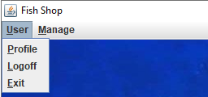
Figure 5. Admin: User Menu

There are 3 JMenuItem available (to be clicked) in User Menu (Profile, Logoff, and Exit).
        - If user clicks Profile, program will open Profile Form inside the Main Form.
        - If user clicks Logout, program will close Main Form and open Login Form.
        - If user clicks Exit, program will be terminated.

      - Manage
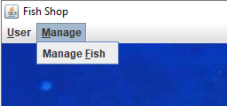
Figure 6. Admin: Manage Menu

There are 1 JMenuItem available (to be clicked) in Manage Menu (Manage Fish).
        - If user clicks Manage Fish, program will open Manage Fish Form inside the Main Form.

- If “Admin” clicks Manage Fish Menu Item, then the program will open Manage Fish Form.

- Buy Fish Form
This form displays all the currently available fish. In this form, user can click any product to see the fish detail and add it to cart. But if the Fish Stock is 0, so the fish detail won’t be shown in the form and can’t be added to cart. In this form, cart is also shown at the bottom view of the form. This form is made with JInternalFrame.
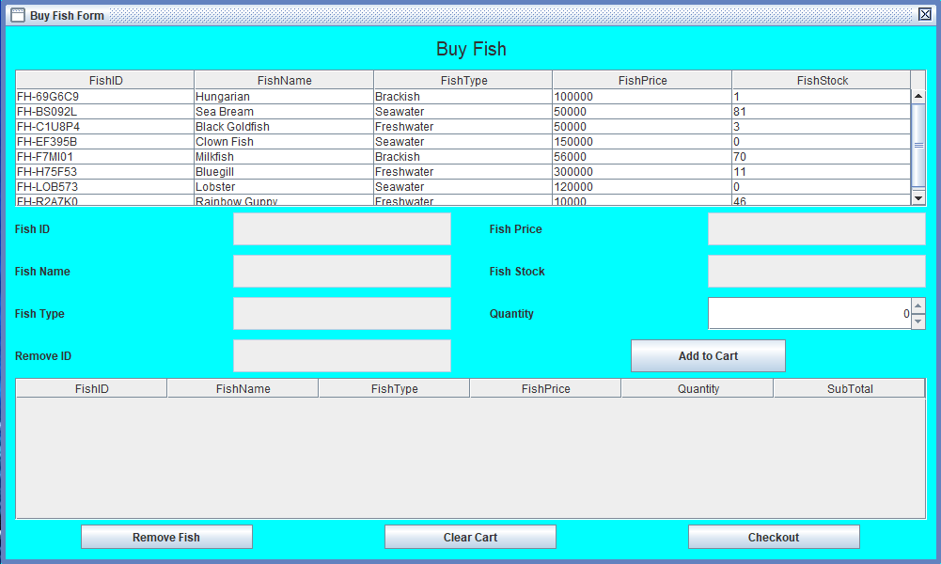
Figure 13. Buy Fish Form
Components:
- JTable for Fish Table and Cart Table.
- JScrollPane for Fish and Cart Table Container.
- JLabel for Title, Fish ID, Fish Name, Fish Type, Fish Price, Fish Stock, Quantity, and Remove ID.
- JTextField (read-only) for Fish ID, Fish Name, Fish Type, Fish Price, Fish Stock, Quantity, and Remove ID.
- JSpinner for input Quantity.
- JButton for Add to Cart, Remove Fish, Clear Cart, and Checkout.

Description:
User can only edit quantity field and the other fields can’t be edited. If user clicks Add to Cart button, program will validate is there any fish chosen or not. If the fish already chosen, then program will validate the quantity that can’t be less than 1 and can’t be more than its Fish Stock. If user choose a fish that currently stock is 0, then program will show warning message.
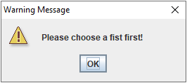
Figure 14. Choose Fish Warning
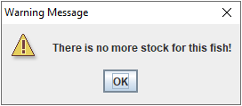
Figure 15. No Stock Warning

If all conditions are fulfilled, then the fish will be added to the user’s cart:
- If the fish hasn’t existed yet, insert new fish to user’s cart and show message.
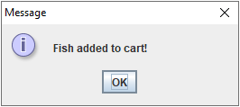
Figure 16. Fish Added Message
- If the fish has existed, update fish quantity with the addition of quantity and show message.
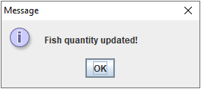
Figure 17. Fish Quantity Added Message
- After the fish added to cart, decrease Fish Stock equals to the quantity.
- User can also remove fish form cart by using Remove Fish button. Validate that the fish from cart must be chosen first by click the fish row that want to be deleted. To see the fish that want to deleted is already clicked or chosen, Remove ID will be contains the selected Fish ID that want to be deleted. After remove fish from cart, shows message.
- After the fish removed from cart, increase Fish Stock equals to the quantity.
- If user clicks Clear Cart button, program will ask confirmation first and if user choose yes, then program will clear the cart and add each fish quantity to Fish Stock.
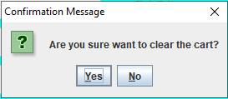
Figure 18. Clear Cart Confirmation
- If user clicks Checkout button, program will ask confirmation first and if user choose yes, then program will clear the cart and insert all fish to Transaction (Header and Detail) and shows message.
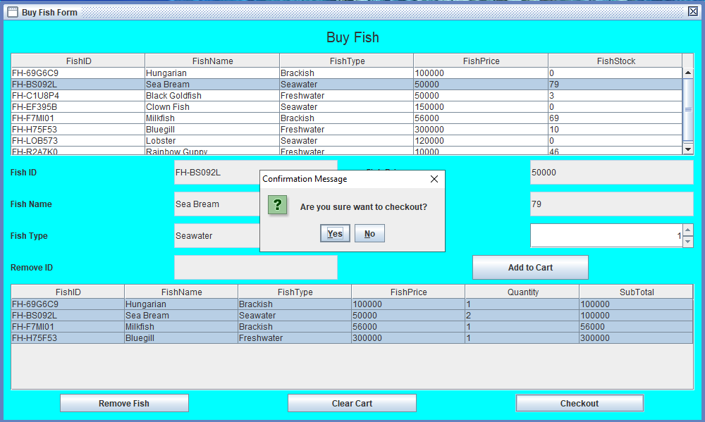
Figure 19. Checkout Confirmation

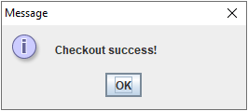
Figure 20. Checkout Success Message
(additional note: every error occurrence will be shown on error message JOptionPane).

- Transaction Form
Transaction Form allows user to view all the transaction history or all transaction that user has made. This form is made with JInternalFrame.

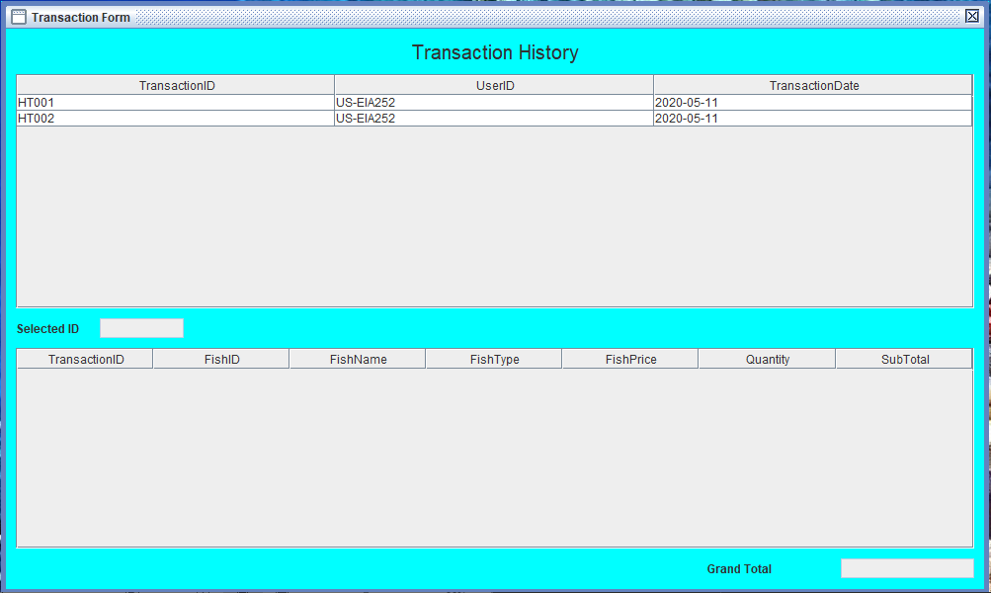
Figure 21. Transaction Form
Components:
- JLabel for Title, Selected ID, Grand Total.
- JTable for Header Transaction Table and Detail Transaction Table.
- JScrollPane for Header and Detail Transaction Table container.
- JTextField (read-only) for Selected ID and Grand Total.

Description:
If user clicks one of the header transaction table, it will show all the detail transaction that user bought on that transaction. It also triggers program to update the Selected ID based on user clicks and Grand Total by sum all the Sub Total of the detail transaction. Sub Total in detail transaction is obtained from calculation between Quantity times Fish Price.
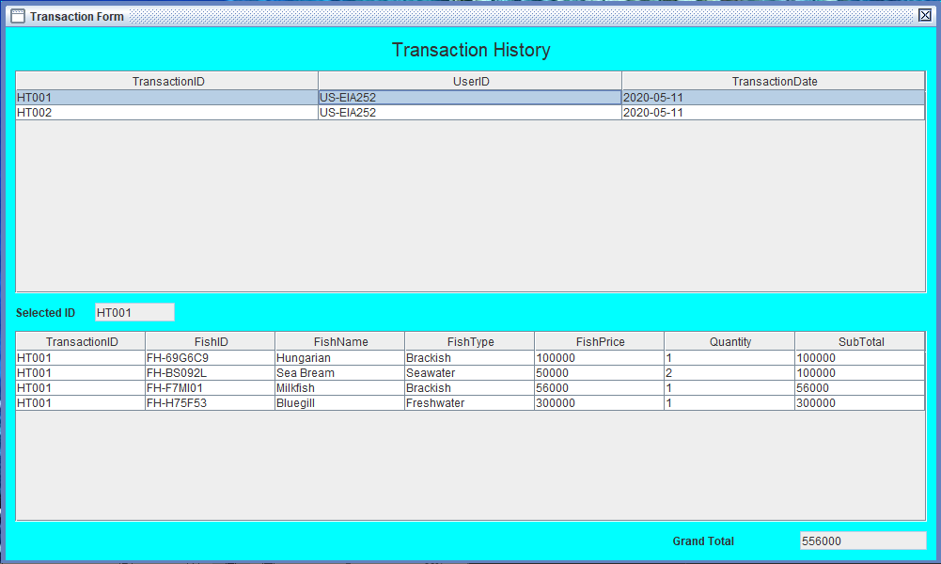
Figure 22. Detail Transaction View
- Manage Fish Form
Manage Fish Form is made for admin to manage fish. Admin can do insert new fish, update any existing fish data, remove/delete fish, and add fish stock. This form is made with JInternalFrame.
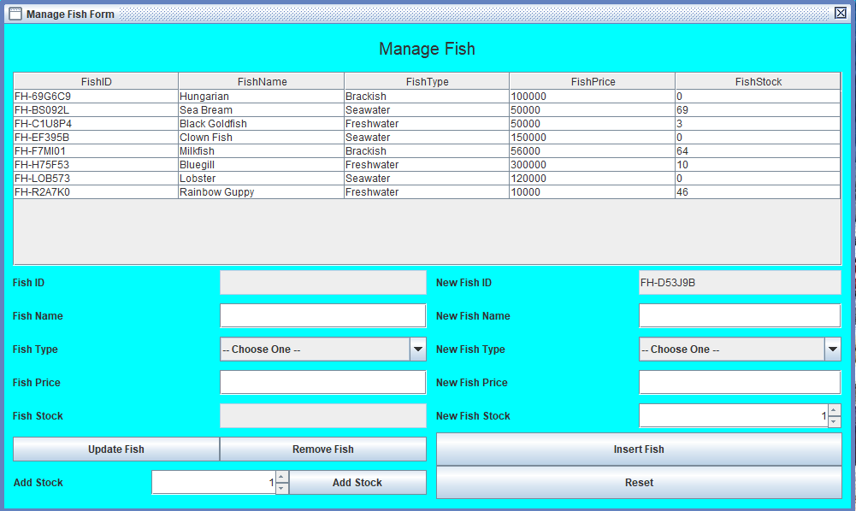
Figure 23. Manage Fish Form
Components:
- JLabel for Title, Fish ID, Fish Name, Fish Type, Fish Price, Fish Stock, Add Stock, New Fish ID, New Fish Name, New Fish Type, New Fish Price, and New Fish Stock.
- JTable for Fish Table.
- JScrollPane for Fish Table container.
- JTextField for input Fish ID (read-only), Fish Name, Fish Price, Fish Stock (read-only), New Fish ID (read-only), New Fish Name, and New Fish Price.
- JComboBox for choose Fish Type and New Fish Type.
- JSpinner for input Add Stock and New Fish Stock.
- JButton for Update Fish, Remove Fish, Add Stock, Insert Fish, and Reset.

Description:
- All the fields can be edited except for Fish ID, New Fish ID, and Fish Stock.
- Admin can do Insert, Update, Delete, and Add Stock fish from database.
  - If admin clicks Update Fish button, then validate:
    - Fish ID is not empty (by click a row in fish table).
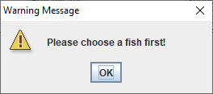
Figure 24. Choose Fish Warning
    - Fish Name must consist of 3 - 25 characters.
    - Fish Type must be chosen either Freshwater, Seawater, or Brackish.
    - Fish Price must between 1000 - 10000000.
  - If all conditions for Update Fish are fulfilled, then program will ask confirmation first and if use choose yes, program will update fish’s data in database.
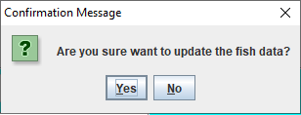
Figure 25. Update Fish Confirmation
  - If admin clicks Remove Fish button, then validate:
    - Fish ID is not empty (by click a row in fish table).
  - If all conditions for Remove Fish are fulfilled, then program will ask confirmation first and if use choose yes, program will delete fish from database.
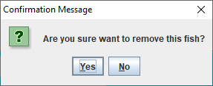
Figure 26. Remove Fish Confirmation
  - If admin clicks Add Stock button, then validate:
    - Fish ID is not empty (by click a row in fish table).
    - Add Stock must between 1 - 100.
  - If all conditions for Add Stock are fulfilled, then program will ask confirmation first and if use choose yes, program will update fish’s stock in database with the addition of Added Stock.
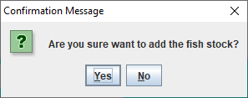
Figure 27. Add Fish Stock Confirmation
  - If admin clicks Insert Fish button, then validate:
    - New Fish ID is generated when Manage Fish Form open with format:
FH-XXXXXX
Where X: Random Digit (0-9) or Uppercase Character (A-Z)
Example: FH -A1R0W2, FH -12UI9P, FH-P9150H

    - New Fish Name must consist of 3 - 25 characters.
    - New Fish Type must be chosen either Freshwater, Seawater, or Brackish.
    - New Fish Price must between 1000 - 10000000.
    - New Fish Stock must between 1 - 100.
  - If all conditions for Insert Fish are fulfilled, then program will ask confirmation first and if use choose yes, program will insert new fish to database.
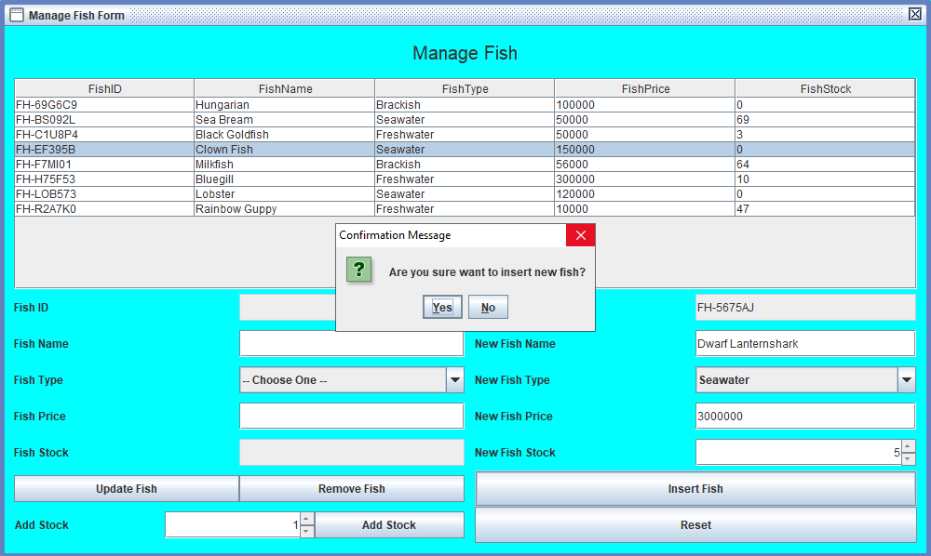
Figure 28. Insert New Fish Confirmation
  - If admin clicks Reset button, then reset all field.
(additional note: every error occurrence will be shown on error message JOptionPane).

- Profile Form
Profile Form allows users to see and update their profile. This form is made with JInternalFrame.
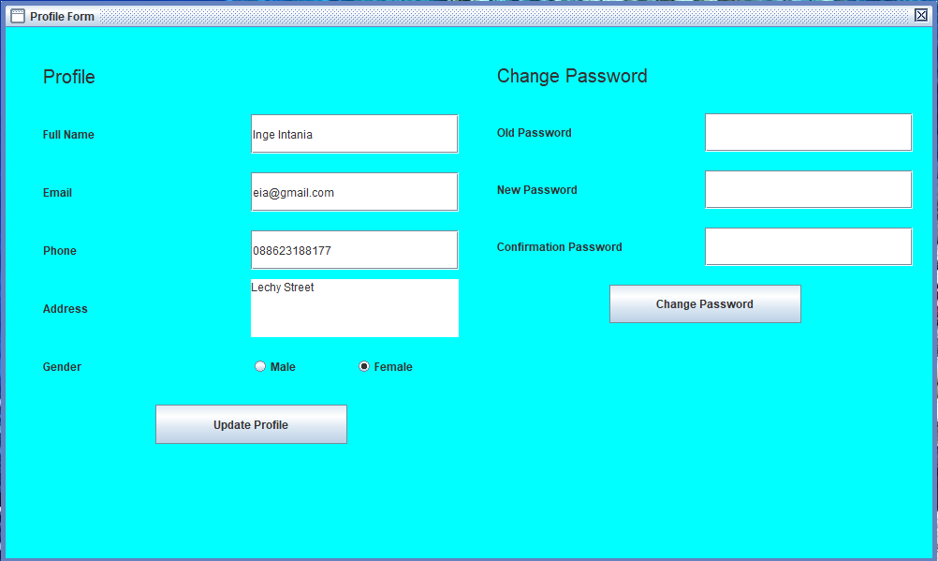
Figure 29. Profile Form
Components:
- JLabel for Profile Title, Full Name, Email, Phone, Address, Gender, Change Password Title, Old Password, New Password, and Confirmation Password.
- JTextField for input Full Name, Email, and Phone.
- JTextArea for input Address.
- JRadioButton for choose Gender (“Male” or “Female”).
- JPasswordField for input Old Password, New Password, and Confirmation Password.
- JButton for Update Profile and Change Password.

Description:
- If user clicks Update Profile button, program will validate:
  - Full Name must be between 5 - 30 characters.
  - Email must haven’t been taken from other account and be in valid format:
[email]@[provider].[domain]
    - Character ‘@’ must not be next to ‘.’.
    - Must not starts and ends with ‘@’ nor ‘.’.
    - Must contain exactly one ‘@’.
    - Must contain exactly one ‘.’ after ‘@’ for separating [provider] and [domain].
  - Phone must haven’t been taken from other account and consist only 10 - 12 digits only.
  - Address must consist of 10 or more characters and ends with ‘ Street’.
  - Gender must be selected either “Male” or “Female”.
- If all conditions for Update Profile are fulfilled, then program will ask confirmation first and if user choose yes, program will update user’s data in database.
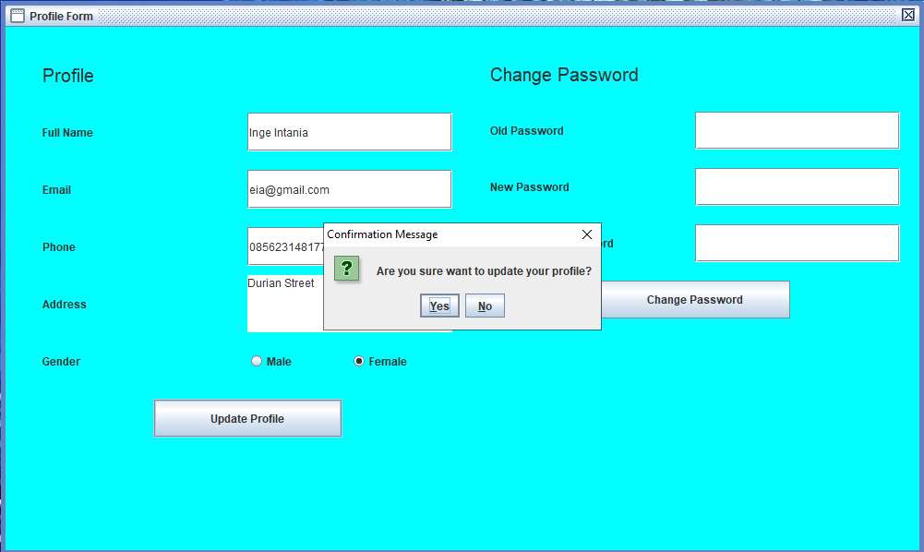
Figure 30. Update Profile Confirmation
- If user clicks Change Password button, program will validate:
  - Old Password must match with user current password.
  - New Password must 8 - 20 length of character and digit (must at least contain 1 character and 1 digit).
  - Confirmation Password must match with New Password.
- If all conditions for Change Password are fulfilled, then program will ask confirmation first and if user choose yes, program will update user’s password in database.

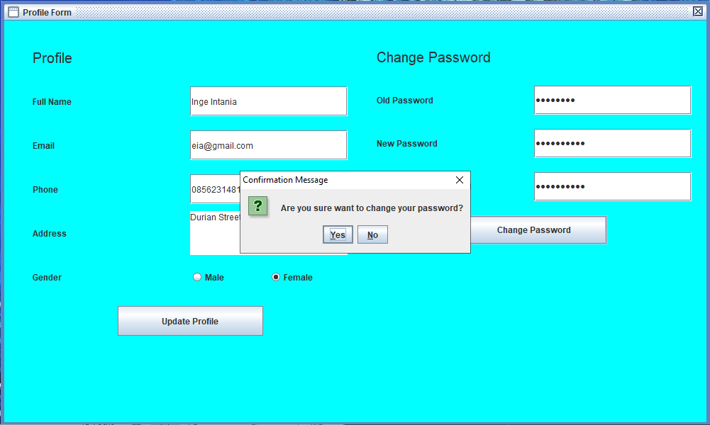
Figure 31. Change Password Confirmation
(additional note: every error occurrence will be shown on error message JOptionPane).

Here are the rules that you must follow to create your project:
- Use appropriate software for this subject based on Sistem Praktikum that can be downloaded from Binusmaya.
- Additional rules:
  - All connections and data manipulation to the database must use the JDBC driver. The database file (using Microsoft Access 2003, .mdb) must be submitted as well.
  - Use LayoutManager to design your application (You are not allowed to use free / absolute / null layout!).
  - All validations must use the techniques taught during practicum. (Another language or Regular Expression is prohibited).
- Collect appropriate files for this subject based on Sistem Praktikum that can be downloaded from Binusmaya.
- Include the other files that can support your project, such as:
  - All files in your project.
  - Other files (image, audio, video, etc.) used in your project.
  - *.DOC file (documentation of your project) that contains all pages in your project, reference links of additional files (image, audio, video, etc.) used in your project, the description about how to use your application, etc.

References:
- https://id.pinterest.com/pin/364087951127927864/

If there is something you don’t understand, feel free to ask your Assistant

